React and ReactJs --> (library)same same and used to create web apps. but,

react Native --> framework --> used to create cross -platform apps like web apps, android, ios

--> follows component based development

--> virtual DOM (Document object model)--> copies actuall dom and stores in virtual dom then compare the actual dom and virtual dom --> that is called DIFF

-->using this DIFF identifies the affected components ,that components and their related components along it takes and updates in actual DOM

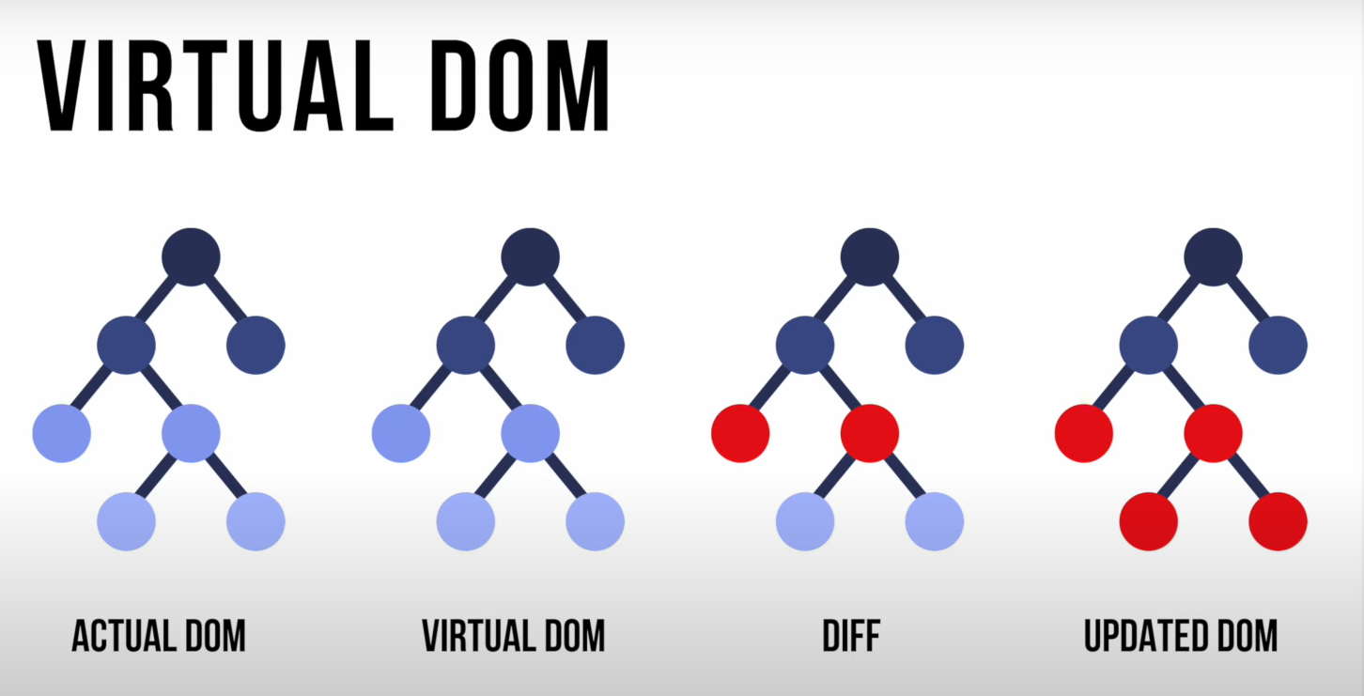

SPA (Single Page Application):

Example:

Google map:🡪 normal view , statellite view

🡪without loading a page , moving to next page or component is called single page application(SPA)